**INTRODUCTION TO MUSIC**

Music has been present since the beginning of civilization. Even in ancient times men made and enjoyed music, by playing very primitive instruments.

Through the passage of time, music has become more and more refined, and the instruments and gadgets have become more sophisticated.

**What is music:** The art of arranging sounds in time so as to produce a continuous, unified, and evocative composition.

A basic definition of music (in the Western World) is the chronological organisation of sounds; that is, making certain sounds at certain times, which make melodic, rhythmic and harmonic sense.

**Important Musical concepts / Components of Music:**

**Rhythm** is the most basic concept of music. In all cultures worldwide, the most simple and basic forms of music are purely rhythms. A rhythm is a pulse; a repetition of sounds in a pattern. Simple rhythms can be recognized straight away. Tapping rhythmically at a drum constitutes tapping it at timed intervals in a pattern.

**Melody:** A pleasing succession or arrangement of sounds. It can be played with an instrument that can produce different pitches, or it can be sung.

**Harmony:** A combination of notes, especially when blended into chords, pleasing to the ear**.**

**Dynamics:** In music, we use the word **dynamics** to describe how loudly or softly a note is played.

**Timbre (tone colour):** Timbre is the difference between the harsh, scratchy sound of an electric guitar with distortion; the glassy, rounded sound of a piano; and the bird-like whispering sound of a flute. All these instruments could play exactly the same note, yet anyone would be able to recognise instantly an Electric Guitar from a piano from a flute.

**Types of Instruments:** There are a very large number of musical instruments, each with its own unique sound and quality. These musical instruments can be divided into 4 basic categories:

- S[tring Instruments](http://www.kidport.com/reflib/music/instruments/StringInstr.htm), like Guitar, Violin, Sitar etc.

- W[ind Instruments](http://www.kidport.com/reflib/music/instruments/WindInstr.htm), like Flute, Mouth Organ, Harmonium etc.

- P[ercussion Instruments](http://www.kidport.com/reflib/music/instruments/PercussionInst.htm), like drums, Dholak, Cymbals etc.

- Electronic instruments, like synthesizer, electric Guitar with gadgets.

**S**[**OLFEGE**](http://en.wikipedia.org/wiki/Solfege) **/ TONIC SOL-FA / SARGAM / PROGRESSION OF NOTES:**

There are basically twelve notes (Swaras), out of which seven are pure notes ( Shuddha) and the rest five are called sharp/flat ( Vikrit). They are grouped in Octaves (Saptak).

**The seven pure notes are:**

|  |  |  |
| --- | --- | --- |
| C | Do | Sa (Shadja) |
| D | Re | Re (Rishabh) |
| E | Mi | Ga (Gandhar) |
| F | Fa | Ma (Madhyam) |
| G | So | Pa (Pancham) |
| A | La | Dha (Dhaivat) |
| B | Ti | Ni (Nishad) |

**Sharp Notes & Flat Notes**

Apart from the seven pure notes, there are also five sharp / flat notes. They are easier to understand through a keyboard.

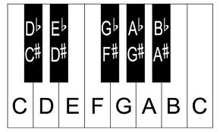

On a Keyboard, A sharp note for a pure note falls on its right. A flat note falls on the left of the pure note. Therefore, C Sharp is same as D Flat.

A Sharp note is written as # and a Flat note is written ashttp://t0.gstatic.com/images?q=tbn:ANd9GcRIa0B9WUZZY2eNjONgWmekcjQax9OSYTLpY2_pBv0E713b7TigNg.

Therefore, C sharp will be written as C# and D flat will be written as Dhttp://t0.gstatic.com/images?q=tbn:ANd9GcRIa0B9WUZZY2eNjONgWmekcjQax9OSYTLpY2_pBv0E713b7TigNg…and so on and so forth.

The sharp notes (or flat notes) are present on the Guitar also, but because we do not have something as clear as black or white keys on a Guitar, they are slightly difficult to understand, especially in the beginning. But if you keep practicing the scales on a Guitar, you will soon be able to locate them with ease.

**LEARNING THE GUITAR:**

It isby far the most popular instrument in the world. And the reasons for its popularity are easy to find: It is easy to carry; it blends with any kind of music; it gives the player all the freedom to develop his / her own style and, above all, it is probably the most versatile instrument. In fact, there are so many different ways to play this instrument, that one may spend a life time, trying to explore all different ways. Little wonder then, that even with the arrival of the digital instruments, the popularity of the Guitar has never declined.

Learning this instrument may take longer than if we are learning any other instrument, but the time spent here is definitely well worth it. In fact, once a person has mastered the Guitar, he / she can use the concepts learnt here on to most other instruments.

**TYPES OF GUITARS**

#### Acoustic Guitars have a sound box through which the sound is amplified. This is the most common type of Guitar.

#### Classical guitars are a variation of Acoustic Guitars. These are typically strung with nylon strings, plucked with the fingers, played in a seated position and are used to play a diversity of musical styles including [classical music](http://en.wikipedia.org/wiki/European_classical_music).

#### A Twelve-string guitar usually has steel strings and is widely used in [folk music](http://en.wikipedia.org/wiki/Folk_music), [blues](http://en.wikipedia.org/wiki/Blues), and [rock and roll](http://en.wikipedia.org/wiki/Rock_and_roll). Rather than having only six strings, the 12-string guitar has six [courses](http://en.wikipedia.org/wiki/Course_(music)) made up of two strings each, like a [mandolin](http://en.wikipedia.org/wiki/Mandolin) or [lute](http://en.wikipedia.org/wiki/Lute). The highest two courses are tuned in unison, while the others are tuned in octaves. The 12-string guitar is also made in electric forms.

**Electric B**[ass Guitar](http://en.wikipedia.org/wiki/Bass_guitar)**s** have 4 or 5 thick strings, tuned one octave lower than the usual six string guitar. They are commonly played in accompaniment to drums / percussion.

**Acoustic bass guitars** have steel strings or gut strings (four or five) and have the same tuning as an electric [bass guitar](http://en.wikipedia.org/wiki/Bass_guitar). They are mostly used to play ‘’unplugged’’ versions.

### Electric Guitars have solid bodies, and produce little sound without amplification. [Electromagnetic](http://en.wikipedia.org/wiki/Electromagnetism) [pickups](http://en.wikipedia.org/wiki/Pickup_(music_technology)) convert the vibration of the steel strings into [signals](http://en.wikipedia.org/wiki/Signal_(electronics)), which are fed to an [amplifier](http://en.wikipedia.org/wiki/Amplifier) through a [cable](http://en.wikipedia.org/wiki/Cable) or [radio](http://en.wikipedia.org/wiki/Radio) [transmitter](http://en.wikipedia.org/wiki/Transmitter).

A **semi-acoustic guitar** or **hollow-body electric** is a type of [electric guitar](http://en.wikipedia.org/wiki/Electric_guitar). It has both a [sound box](http://en.wikipedia.org/wiki/Sound_box) and one or more electric [pickups](http://en.wikipedia.org/wiki/Pick_up_(music_technology)). So it does produce some sound without amplification, but not as much as an acoustic Guitar.

### DIFFERENT WAYS TO PLAY THE GUITAR: It is not for nothing that the Guitar is called the most versatile instrument. Often, it is a complete orchestra on its own. The various ways in which you can play this instrument are:

**- Rhythm:** Giving a regular beat to a song with chords.

**- Lead:** Playing the melody or playing interludes / fillers.

**- Bass:** Whether through an electric bass guitar or acoustic bass guitar. A good Bass line adds a new dimension to a musical piece.

**- Plucking:** Usually done with the nails of the right hand. It mostly suits country music or any soft music, but some rock Guitarists also use plucking to a great effect. Plucking often gives the impression of more

than one Guitar playing at the same time, if the listener is not watching.

**PARTS OF THE GUITAR:**

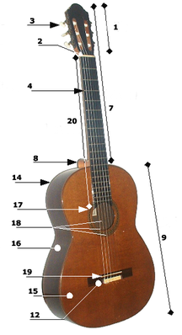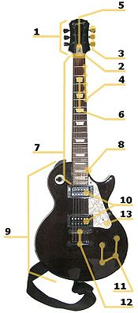

1. [Headstock](http://en.wikipedia.org/wiki/Guitar#Headstock)
2. [Nut](http://en.wikipedia.org/wiki/Guitar#Nut)
3. Tuning keys
4. [Frets](http://en.wikipedia.org/wiki/Guitar#Frets)
5. [Truss rod](http://en.wikipedia.org/wiki/Guitar#Truss_rod)
6. [Inlays](http://en.wikipedia.org/wiki/Guitar#Inlays)
7. [Neck](http://en.wikipedia.org/wiki/Guitar#Neck)
8. [Heel (acoustic)](http://en.wikipedia.org/wiki/Guitar#Neck_joint_or_.22heel.22) Neck joint (electric)
9. [Body](http://en.wikipedia.org/wiki/Guitar#Body_.28acoustic_guitar.29)
10. [Pickups](http://en.wikipedia.org/wiki/Guitar#Pickups)
11. [Electronics](http://en.wikipedia.org/wiki/Guitar#Electronics)
12. [Bridge](http://en.wikipedia.org/wiki/Guitar#Bridge)
13. [Pick guard](http://en.wikipedia.org/wiki/Guitar#Pickguard)
14. Back
15. [Soundboard](http://en.wikipedia.org/wiki/Sound_board_(music)) (top)
16. Body sides (ribs)
17. [Sound hole](http://en.wikipedia.org/wiki/Sound_hole), with [Rosette](http://en.wikipedia.org/wiki/Rosette_(design)) inlay
18. [Strings](http://en.wikipedia.org/wiki/Guitar#Strings)
19. [Saddle](http://en.wikipedia.org/wiki/Guitar#Saddle)
20. [Fret board](http://en.wikipedia.org/wiki/Guitar#Fretboard) (or Fingerboard)

**HOLDING THE GUITAR:**

Now that we know about the basic parts of a guitar, it's time to get busy, and start learning to play it. Get yourself an armless chair. You should be sitting comfortably, with your back against the back of the chair. Slouching is a no-no - otherwise you will end up with a sore back, and you will develop bad habits on the guitar.

Now, pick up your guitar, and hold it so the back of the body of the instrument comes in contact with your stomach/chest, and the bottom of the neck runs roughly parallel to the floor.

When playing the guitar sitting down, the body of the guitar will rest on your right leg.

 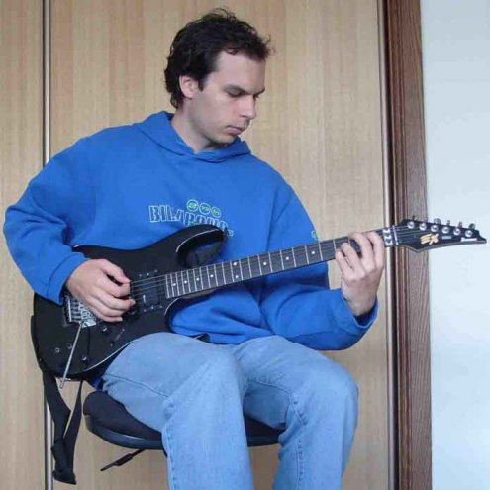

**Holding the Plectrum/Pick:** It is surprising this aspect of guitar playingis not given the kind of importance it merits. But I consider it is my responsibility to let you know its significance right at this stage, because once you get a wrong habit, it is very difficult to get rid of it later. A proper way of holding the plectrum is not only pleasing to the eye; it also gives you better control and variation in playing.

### You should hold the plectrum gently, applying just enough force, so that it does not fall off. The only finger to touch it should be the index finger, apart from the thumb, like this:

### http://t0.gstatic.com/images?q=tbn:ANd9GcQib40H8O3MsBFC36QTvHtjcj7KQqWhx02JAp8V2g9yCNKXH4n0http://www.guitarscholar.co.uk/i/Basic%20Skills/strumminggrip.jpg

Some players might start by holding the plectrum between the thumb and the middle finger. This may seem comfortable initially, but as you enter into the depth of playing, this will feel uncomfortable. At that stage, it may be difficult to get rid of the habit of holding the plectrum wrongly.

Also, make sure that only the tip of the plectrum is protruding from between the thumb and the index finger, or else you will tend to break the strings and the plectrum too often. Moreover, you will tend to get a rather harsh ‘’plastic’’ sound from the strings.

By the way, there are many good Guitarists who do not use a plectrum!

### Advantages of finger style (no plectrum):

- Having a pick isn’t necessary

- It is possible to play multiple non-adjacent strings at exactly the same time

- It is more suitable for playing [polyphonically](http://en.wikipedia.org/wiki/Polyphonically), with separate musical lines,

or separate [melody](http://en.wikipedia.org/wiki/Melody), [harmony](http://en.wikipedia.org/wiki/Harmony) and [bass](http://en.wikipedia.org/wiki/Bass_(sound)), and therefore more suitable to unaccompanied soloing.

- It is easy to play [arpeggios](http://en.wikipedia.org/wiki/Arpeggios).

- A greater variation in strokes is possible, allowing greater expressiveness in [timbre](http://en.wikipedia.org/wiki/Timbre).

- A wide variety of strums are possible.

- It can be applied to almost any [genre](http://en.wikipedia.org/wiki/Genre). Even some [rock](http://en.wikipedia.org/wiki/Rock_music) guitarists use finger style.

**Advantages of using a pick:**

**-** Fingernails do not have to be maintained at the right length and in good condition.

**-** Involves less multi-tasking which makes it easier to do; requires less practice.

**-** Picking back and forth with a pick is much easier. A[lternate picking](http://en.wikipedia.org/wiki/Alternate_picking) is usually the most efficient

**t**echnique.

**-** [Tremolo](http://en.wikipedia.org/wiki/Tremolo) effects are easier to achieve.

- More energy is generally imparted to strings, leading to greater volume when playing acoustically.

- There is less loss of articulation or clarity when playing fast.

- Plectrum strokes are even, facilitating smooth melody lines, whereas individual fingers have different

sizes and levels of strength.

- Playing on heavier gauge strings can damage nails: finger style is more suited to nylon strings or lighter

gauge steel strings (but this does not apply to fingerpicks).

**GUITAR STRING NAMES (Notes) AND NUMBERS:**

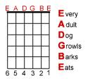

The notes can also be memorized as: **Elephants And Donkeys Grow Big Ears.**

**FINGER NUMBERS:**

For the purpose of easy illustration, the fingers on the left hand can be numbered as below:

